**11SEN1 Notes**

**Notes -**

Text – string

0 to 9 – integer

True or false – bool/Boolean

Variable – reserved memory to store data values

**Code and Description of what it does -**

The code on the right allows the user to give a number to the script and the script would mathematically double it and give the 2x answer.

The code on the left prints “Welcome from Kingsgrove High School”, but has been separated in different groups of text to show as one.

The code on the left allows the user to enter their name and password, with the script outputting and telling the user their given username and password.

The code on the right is an incorrect version of ‘integer’ coding and literally doubles the number as it thinks its text and not an integer.

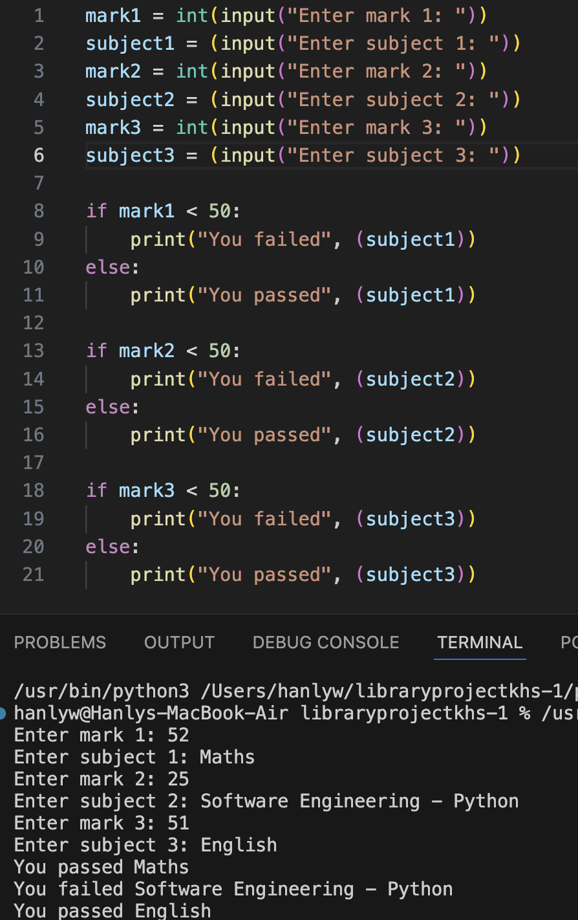The code on the left asks the user to give 3 marks & subjects, and checks if they pass.

The code below simply prints the first name already added into the script.

The code on the right simply multiplies any number by two.

The code on the left is a revamp of the mark system, allowing three subjects and marks to be given while ensuring the user inputs a 0-100 integer/mark.

The code above prints the numbers 1 to 10. Code also ensures not to print 0.

The code on the right asks for input of a mark as an integer and tells the user whether they have passed or not.

The code on the right has the first number going from 0 to 9, and second number being the sum but being added with first number to create new sum.

Code on left prints one to five in words using data array system and index print system.

The code on the right prints a variable from a array. It prints a specific variable, not a range, which allows for individual variables to be printed.

The code on the left prints all variables using for loop.

The code below tells you how many characters is in the input that user gives to script.

This part of code is the login system, with an attempt system for if the user inputs an invalid username and/or password. It gives a welcome message to the user once they successfully login.

This part of code runs operation 1 (list all books without worrying about availability), listing its index from one to fifteen, with the names and book code.

This part of code runs operation 2 (list all available books), listing its index from one to eight, with the names and book code.

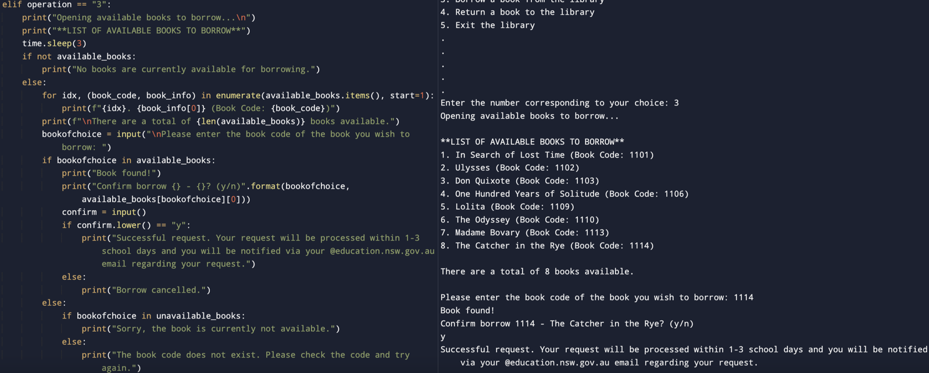This part of code runs operation 3 (borrow a book), listing its index of available books from one to eight, with the names and book code, allowing user to input an book code and borrow the book

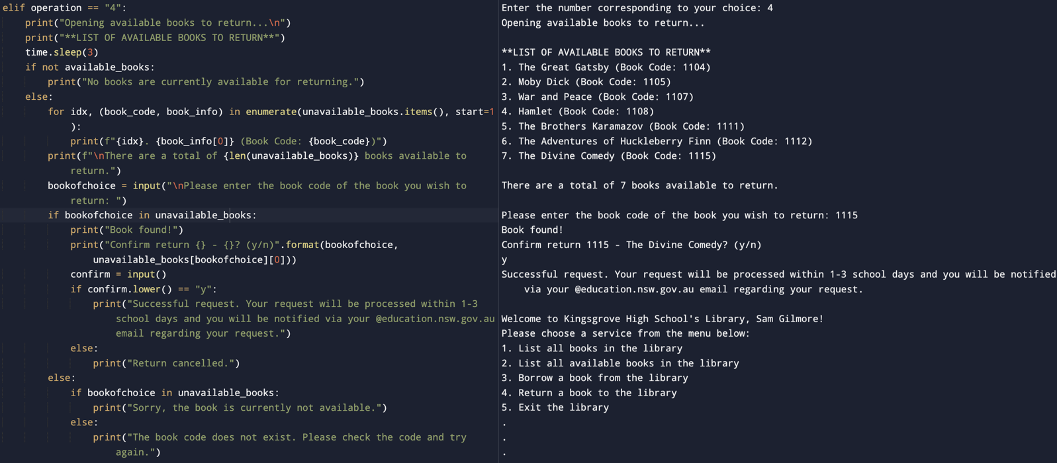This part of code runs operation 4 (return a book), listing its index of unavailable books from one to seven, with the names and book code, allowing user to input an book code and return the book.

This part of code runs operation 5 (exit the program), and it asks the user if they are sure to exit, then gives a smiley face once they confirm. If they do not confirm, they will be in a loop and sent back to the operations menu.